Slacker

Computer Science(083) Project

Developed By

Dhruv Sehgal [14681994]

Rushil Saini [14682010]

Nikunj Rai Juneja [14681997]

GD Goenka Public School, Vasant Kunj

New Delhi

Index

| Sno | Description | Pageno |
| --- | --- | --- |
| 1 | Certificate | 3 |
| 2 | Acknowledgement & References | 4 |
| 3 | Introduction | 5 |
| 4 | Source Code | 7 |
| 5 | Output Screen | 13 |
| 6 | Hardware & Software requirement | 21 |

**Certificate**

This is to certify that ‘Slacker' Computer Science project is developed by Dhruv Sehgal, Rushil Saini and Nikunj Rai Juneja under my supervision in the computer lab of G.D. Goenka Public School, Vasant Kunj in the session 2022-23. The work done by them is original.

Menika Anand

Computer Science Teacher

Date: ____________

Acknowledgement

I would like to express my sincere gratitude to my computer teacher Menika Anand for her vital support, guidance and encouragement without which this project would not come forth from my side. Our teacher helped us complete the project by giving ideas, thoughts and made this project easy and accurate. She inspired us to take up an original project and assured us that it would also help us in honing our programming skills and give depth to our understanding of the Python Language.

Dhruv Sehgal

Rushil Saini

Nikunj Rai Juneja

**Introduction**

What is this project about ?

‘Slacker’ is a program that records your sleep data and gives you an outline of your sleep quality according to your age. It is easy and convenient to use for all age groups. It has a password verification feature to keep your details confidential.

Why the name ‘slacker’?

A shorter form of saying sleep tracker. Also, the name tells you if you are ‘slacking’ on your sleep quality.

Why a sleep tracker?

With increasing number of distractions such as smartphones, streaming services, video games and also other obligations such as school and office work, people often forget the importance of sleep, believing it to be a waste of time. However, this has led to a rise in health-related problems among the youth, leading to decrease in their productivity and quality of life. Our project aims at making sleep tracking convenient for all, and analyzing where they need to improve.

**MySQL Database and Tables**

**##to store all tables required**

**create database sleeptracker;**

**use sleeptracker;**

**##to store userdata**

**create table user(**

**userid int primary key auto_increment,**

**password varchar(20),**

**name varchar(20)**

**age int,**

**BMI int);**

**##to store sleepdata of all users**

**create table tracker(**

**weekno int,**

**userid int,**

**day int,**

**hours int,**

**quality int);**

**Source Code**

**Project Title: Slacker  
Version : 3.9.6**

**Developed By : Dhruv Sehgal, Rushil Saini, Nikunj Rai Juneja  
School : GD Goenka Public School, Vasant Kunj**

**#---------------------------------------------------------------------**

**import mysql.connector as mys #module used**

**mycon = mys.connect(host = "localhost", user = "root", passwd = "12345", database = "sleeptracker") #establishing connection**

**mycursor = mycon.cursor() #creating cursor object**

**#function used to verify password**

**def pwd_check():**

**id_ = int(input("\nEnter user ID : "))**

**pwd = input("Enter password: ")**

**q = "select * from users where userid = {}".format (id_)**

**mycursor.execute(q)**

**rec = mycursor.fetchone() #taking a record of user to verify password**

**if rec[1] != pwd:**

**return False, None #None included because all functions make use of chk[0], the return variable used for pwd_check()**

**else:**

**return True, id_ #returning id since following functions require it**

**#chk[0] is used in all functions in if: clause since pwd_check returns (True, id_) or (False, None) tuple**

**#function for a user to view their records**

**def viewuser():**

**chk = pwd_check()**

**if chk[0]:**

**q = "select * from users where userid = {}".format (chk[1]) #fetching record of user with id specified**

**mycursor.execute(q)**

**rec = mycursor.fetchone()**

**print(f"\nUser ID = {rec[0]}")**

**print(f"Name = {rec[2]}")**

**print(f"Age = {rec[3]}")**

**else:**

**print("wrong password!")**

**#function for adding a new user to the database**

**def adduser():**

**pwd = input("\nSet password: ")**

**name = input("Enter name: ")**

**age = int(input("Enter age: "))**

**q = "insert into users(password, name, age) values('{}', '{}', {})".format (pwd, name, age)**

**mycursor.execute(q)**

**mycon.commit() #updating actual database**

**q1 = "select * from users"**

**mycursor.execute(q1)**

**id_retr = mycursor.fetchall() #to display user data**

**id_ = id_retr[-1][0]**

**print("\nYour profile:")**

**print(f"ID: {id_}")**

**print(f"Name: {name}")**

**print(f"Age: {age}")**

**def modifyuser():**

**print("\n1. name\n2. age")**

**chg = int(input("Enter data to be changed: "))**

**#for changing name of user**

**if chg == 1:**

**chk = pwd_check()**

**if chk[0]:**

**nname = input("Enter updated name: ")**

**q = "update users set name = '{}' where userid = {}".format (nname, chk[1])**

**mycursor.execute(q)**

**else:**

**print("wrong password!")**

**#for changing age of user**

**elif chg == 2:**

**chk = pwd_check()**

**if chk[0]:**

**nage = int(input("Enter updated age: "))**

**q = "update users set age = {} where userid = {}".format (nage, chk[1])**

**mycursor.execute(q)**

**else:**

**print("wrong password!")**

**else:**

**print("invalid input, try again")**

**mycon.commit() #updating actual database**

**def addsleep():**

**chk = pwd_check()**

**if chk[0]:**

**hr = int(input("Enter hours slept : "))**

**qlt = int(input("Enter quality of sleep(1-10) : "))**

**w = "select week(now())"**

**mycursor.execute(w)**

**wnt = mycursor.fetchone() #week number record**

**wn = wnt[0] #week number**

**d = "select weekday(now())"**

**mycursor.execute(d)**

**dyt = mycursor.fetchone() #day number record**

**dy = dyt[0] #day number**

**#0 = Monday, 1 = Tuesday, 2 = Wednesday, 3 = Thursday, 4 = Friday, 5 = Saturday, 6 = Sunday**

**q = "insert into tracker values({}, {}, {}, {}, {})".format (wn, chk[1], dy, hr, qlt)**

**mycursor.execute(q)**

**mycon.commit() #updating actual database**

**else:**

**print("wrong password!")**

**def viewsleep():**

**chk = pwd_check()**

**if chk[0]:**

**day = {0: "Monday", 1: "Tuesday", 2: "Wednesday", 3: "Thursday", 4: "Friday", 5: "Saturday", 6: "Sunday"} #since daynumber if stored int type**

**q = "select * from tracker where userid = {}".format (chk[1])**

**mycursor.execute(q)**

**sleepdata = mycursor.fetchall() #all sleep entries of user till date**

**if sleepdata:**

**for rec in sleepdata:**

**print(f"\nweekno = {rec[0]}")**

**print(f"day = {day[rec[2]]}")**

**print(f"hours = {rec[3]}")**

**print(f"quality = {rec[4]}")**

**else:**

**print("no data to be displayed")**

**else:**

**print("wrong password!")**

**#for all functions related to data of users**

**def usermenu():**

**print("\n1. View user\n2. Add user\n3. Modify user\n4. Main menu")**

**uopt = int(input("Enter choice number : "))**

**if uopt == 1:**

**viewuser()**

**elif uopt == 2:**

**adduser()**

**elif uopt == 3:**

**modifyuser()**

**elif uopt == 4:**

**return**

**#for all functions related to a specific user's sleep data**

**def trackermenu():**

**print("\n1. Add sleep data\n2. View sleep data\n3. Main menu")**

**topt = int(input("Enter choice number : "))**

**if topt == 1:**

**addsleep()**

**if topt == 2:**

**viewsleep()**

**elif topt == 3:**

**return**

**#to view sleep report of a specific user**

**def reportmenu():**

**chk = pwd_check()**

**if chk[0]:**

**q1 = "select age from users where userid = {}".format (chk[1])**

**mycursor.execute(q1)**

**aget = mycursor.fetchone()**

**age = aget[0]**

**q2 = "select avg(hours), avg(quality) from tracker where userid = {}".format (chk[1])**

**mycursor.execute(q2)**

**recs = mycursor.fetchone()**

**avghr = recs[0]**

**avgq = recs[1]**

**print(f"Your average sleep quality reported: {avgq}")**

**if age < 1:**

**print("\nYour ideal sleep range = 13-16 hours")**

**print(f"Your average sleep per night = {avghr}")**

**if avghr < 13:**

**print("Result: Undersleeping")**

**elif avghr > 16:**

**print("Result: Oversleeping")**

**else:**

**print("Result: Healthy amount of sleep")**

**elif 1 <= age <= 2:**

**print("Your ideal sleep range = 11-14 hours")**

**print(f"Your average sleep per night = {avghr}")**

**if avghr < 11:**

**print("Result: Undersleeping")**

**elif avghr > 14:**

**print("Result: Oversleeping")**

**else:**

**print("Result: Healthy amount of sleep")**

**elif 3 <= age <= 5:**

**print("Your ideal sleep range = 10-13 hours")**

**print(f"Your average sleep per night = {avghr}")**

**if avghr < 10:**

**print("Result: Undersleeping")**

**elif avghr > 13:**

**print("Result: Oversleeping")**

**else:**

**print("Result: Healthy amount of sleep")**

**elif 6 <= age <= 13:**

**print("Your ideal sleep range = 9-11 hours")**

**print(f"Your average sleep per night = {avghr}")**

**if avghr < 9:**

**print("Result: Undersleeping")**

**elif avghr > 11:**

**print("Result: Oversleeping")**

**else:**

**print("Result: Healthy amount of sleep")**

**elif 14 <= age <= 17:**

**print("Your ideal sleep range = 8-10 hours")**

**print(f"Your average sleep per night = {avghr}")**

**if avghr < 8:**

**print("Result: Undersleeping")**

**elif avghr > 10:**

**print("Result: Oversleeping")**

**else:**

**print("Result: Healthy amount of sleep")**

**elif 18 <= age <= 64:**

**print("Your ideal sleep range = 7-9 hours")**

**print(f"Your average sleep per night = {avghr}")**

**if avghr < 7:**

**print("Result: Undersleeping")**

**elif avghr > 9:**

**print("Result: Oversleeping")**

**else:**

**print("Result: Healthy amount of sleep")**

**elif age >= 65:**

**print("Your ideal sleep range = 7-8 hours")**

**print(f"Your average sleep per night = {avghr}")**

**if avghr < 7:**

**print("Result: Undersleeping")**

**elif avghr > 8:**

**print("Result: Oversleeping")**

**else:**

**print("Result: Healthy amount of sleep")**

**else:**

**print("wrong password!")**

**#mainmenu, to access all sub-functions**

**print("Welcome to SleepTracker!")**

**while True:**

**print("\n1. User Management\n2. Tracker\n3. Reports\n4. Exit")**

**opt = int(input("Enter choice number : "))**

**if opt == 1:**

**usermenu()**

**elif opt == 2:**

**trackermenu()**

**elif opt == 3:**

**reportmenu()**

**elif opt == 4: #terminating program**

**print("\nThank you for using SleepTracker!")**

**print("Credits:\nDhruv Sehgal\nRushil Saini\nNikunj Rai Juneja")**

**break**

**Sample Outputs**

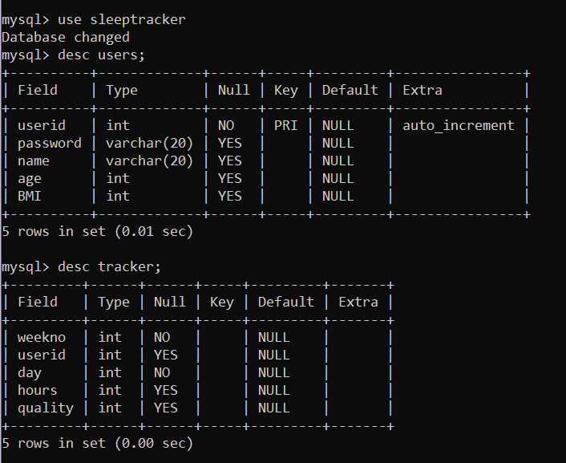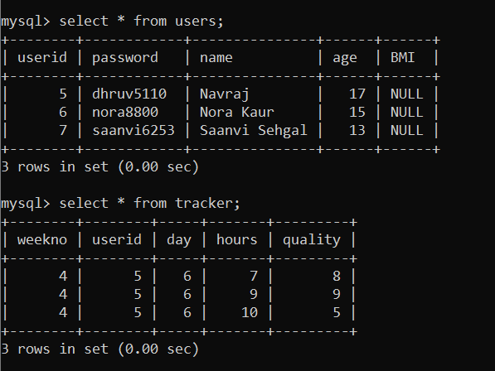

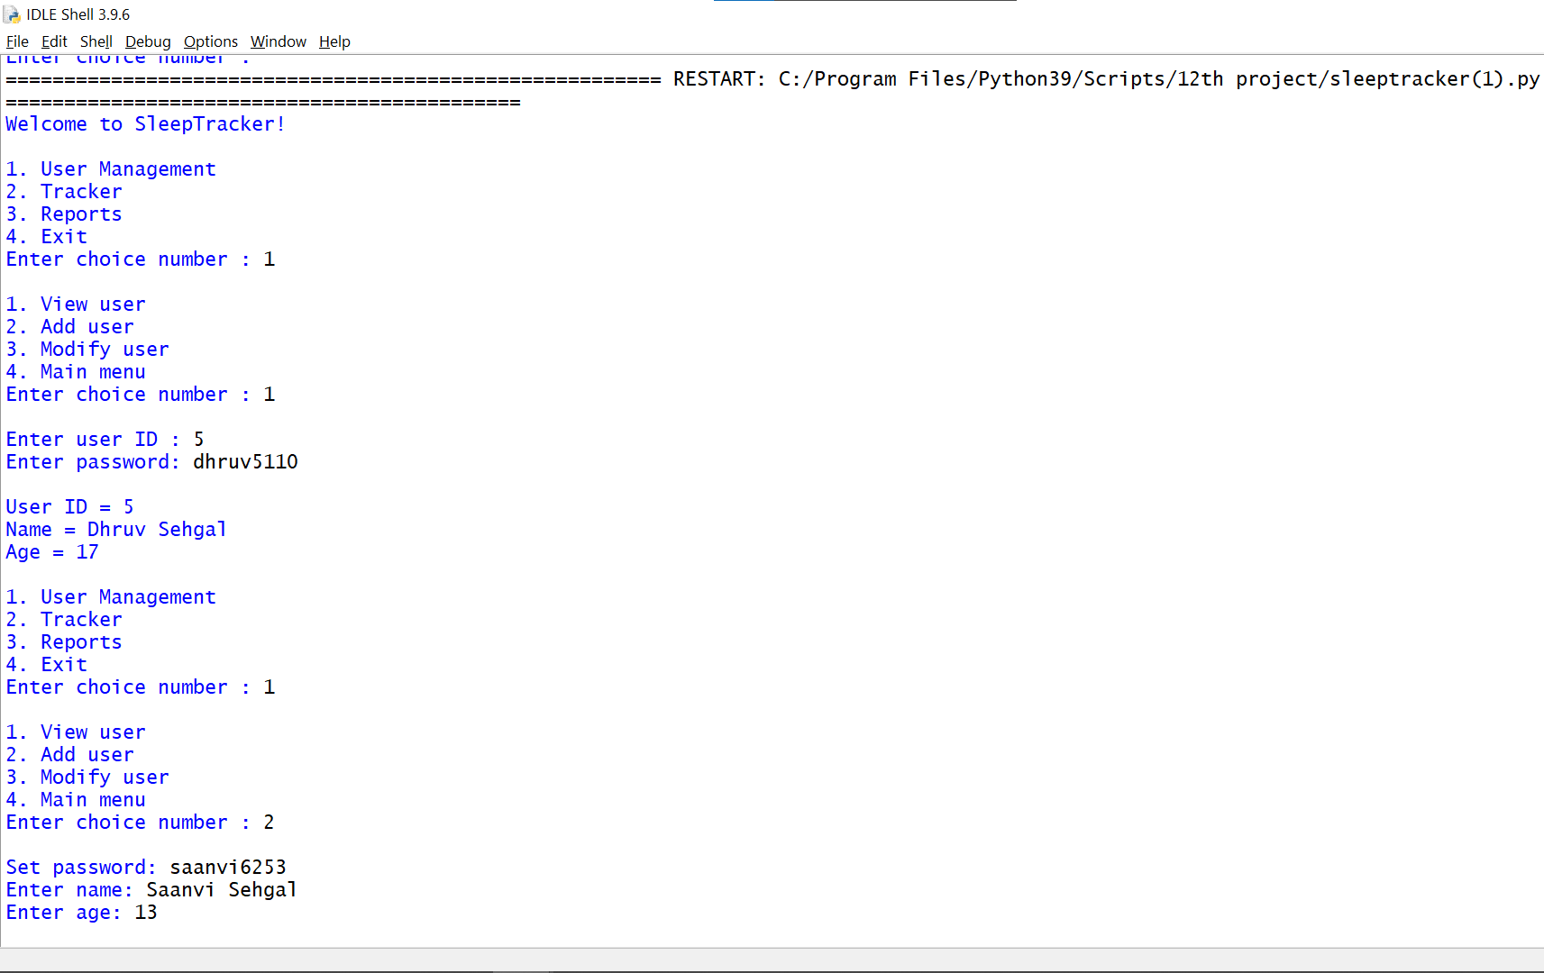

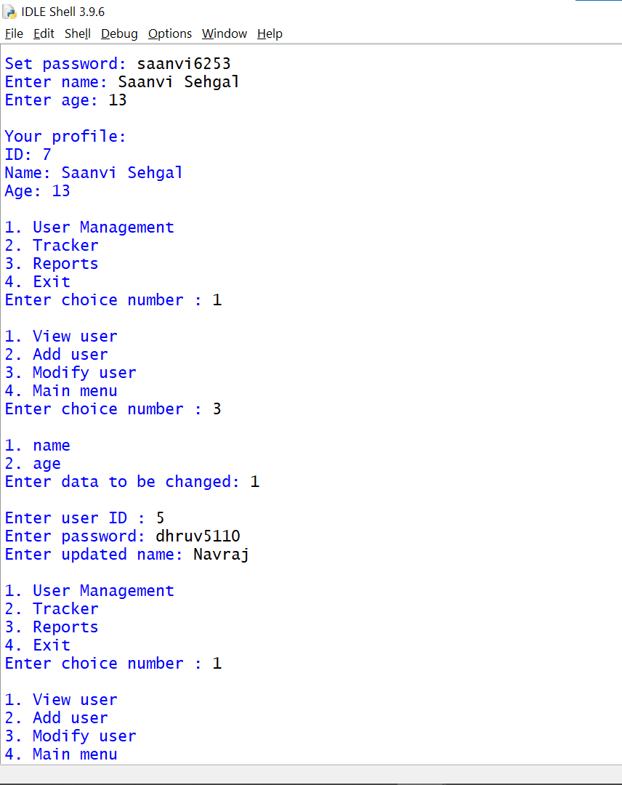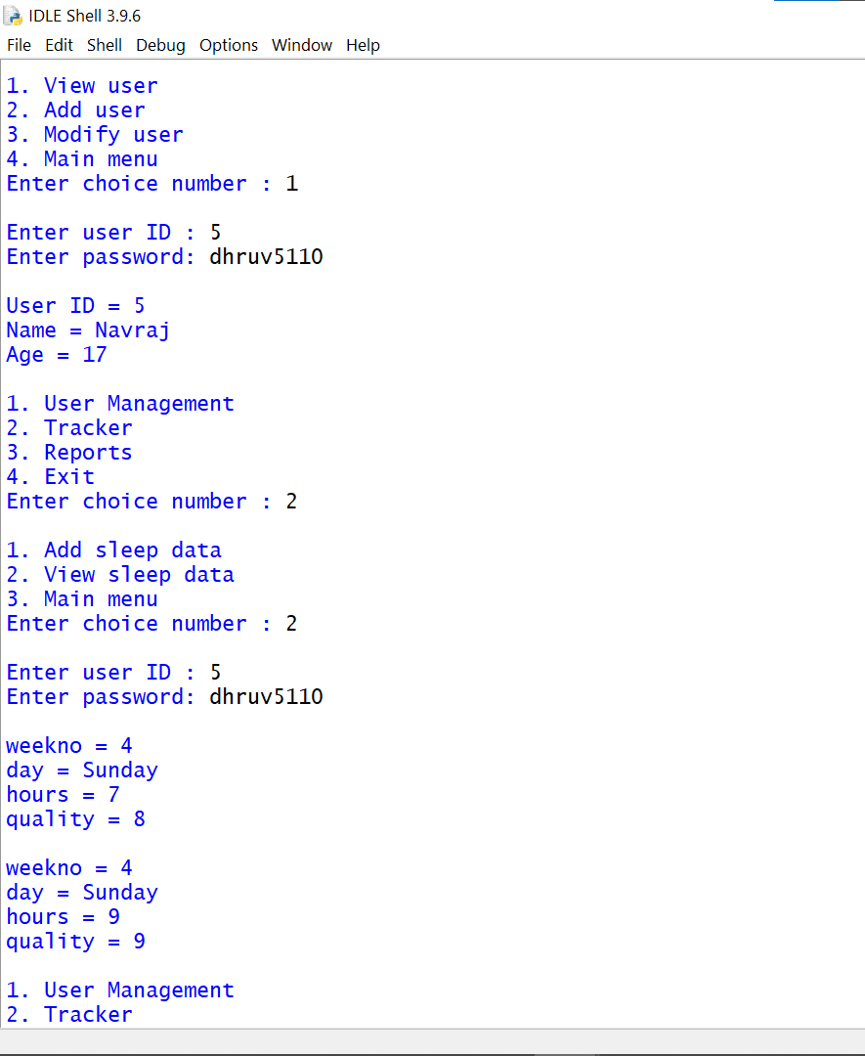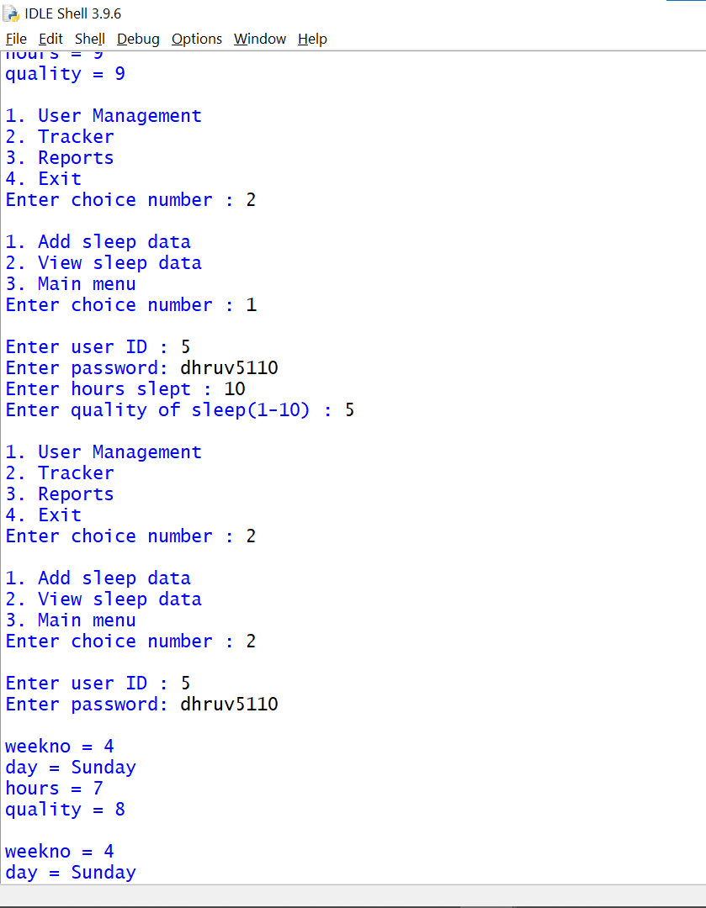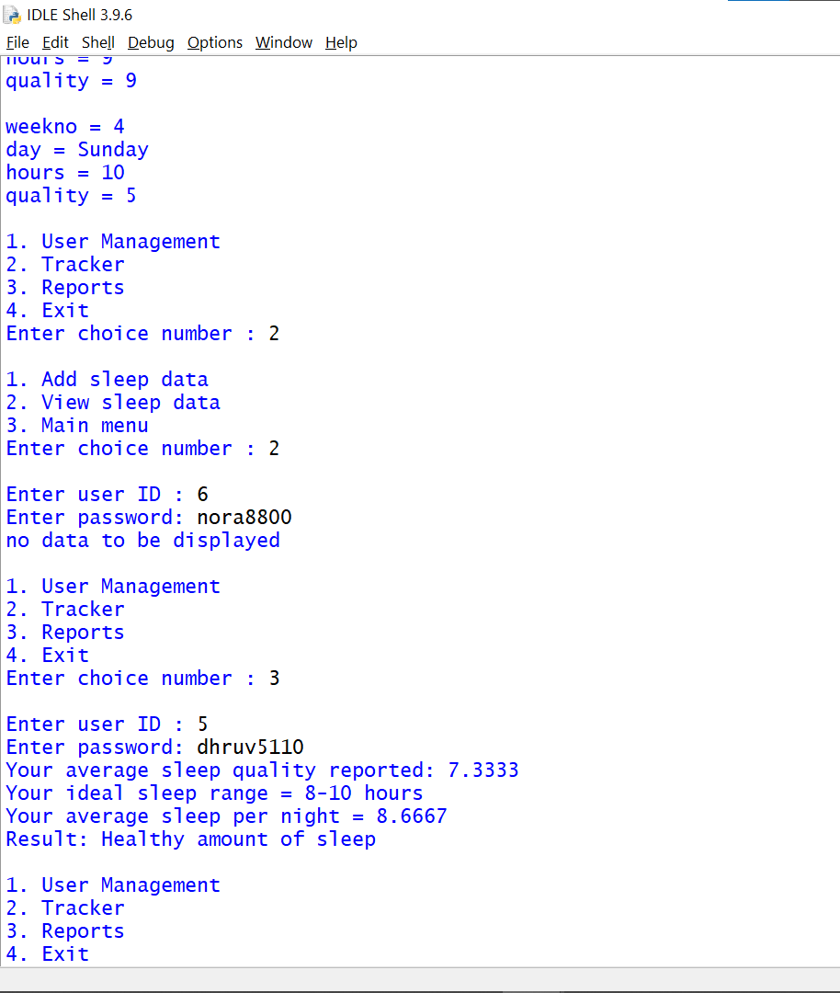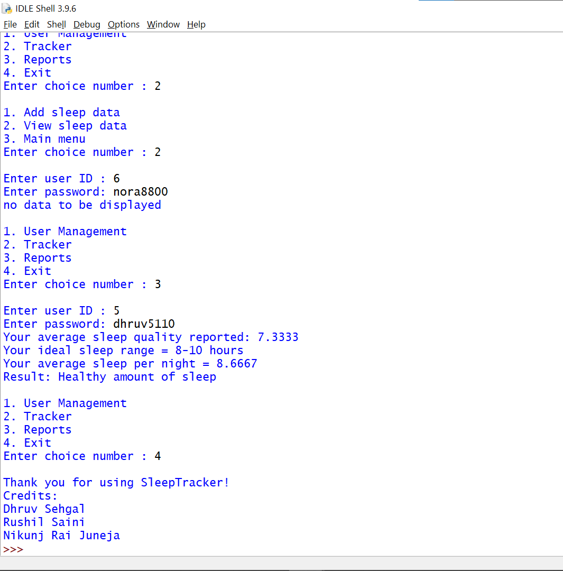

Hardware & Software Requirement

Hardware Requirement

Pentium 3/4/Core 2 Duo/Dual core/i3/i5/i7

With at least 1 GB RAM

2 MB free space on Hard Disk

Operating System & Compiler

MS Windows

Python 3.10